3D Freehand Ultrasound for Medical Assistance in Diagnosis and Treatment of Breast Cancer: Preliminary Results

Fabian Torresª*, Fernando Arambula Cosioª, Zian Fanti^{b}
ªDoctorate in Electrical Engineering and Digital Signal Processing, Center of Applied Science and Technological Development, Universidad Nacional Autónoma de México (UNAM), 04510 México, D.F., México;

^{b}Doctorate in Science and Computational Engineering, Investigation Institute of Applied Mathematics and Systems, Universidad Nacional Autónoma de México (UNAM), 04510 México, D.F., México.

Abstract
Image-guided interventions allow the physician to have a better planning and visualization of a procedure. 3D freehand ultrasound is a non-invasive and low-cost imaging tool that can be used to assist in medical procedures. This tool can be used in the diagnosis and treatment of breast cancer. There are common medical practices that involve large needles to obtain an accurate diagnosis and treatment of breast cancer. In this study we propose the use of 3D freehand ultrasound for planning and guiding such procedures as core needle biopsy and radiofrequency ablation. The proposed system will help the physician to identify the lesion area, using image-processing techniques in the 3d freehand ultrasound images, and guide the needle to this area using the information of position and orientation of the surgical tools. We think that this system can upgrade the accuracy and efficiency of these procedures.

Keywords: Breast cancer, 3D freehand ultrasound, core needle biopsy, image segmentation.

INTRODUCTION
Ultrasound has become a useful tool for assisting medical diagnosis and procedures because it has some advantages over other imaging modalities such as magnetic resonance (MR) or computer tomography (CT). Ultrasound is a minimal invasion and low-cost imaging modality; it also has the ability to obtain real time images of a wide area of the patient anatomy in several directions [Halliwell].
Breast cancer is one of the leading causes of death in women all around the world, so an early and accurate diagnosis is crucial for a successful treatment [Jiao Seg]. Ultrasound imaging of breast cancer has been used as one of the gold standards for breast cancer imaging, since the physicians are able to visualize in real time some characteristics of the tumor that may differentiating it as malignant or benign [Huang Grapho]. However, the must accurate method for breast cancer diagnosis is the biopsy [Badawi], with a sensitivity of 92% when the tumor has a size between 1.8 and 3 cm [Luechakiesttisak]. Because of this, ultrasound-guided needle biopsy has become a common practice to obtain an accurate diagnosis of breast cancer; in fact, the National Institute for Clinical Excellence recommends the use of ultrasound in all selective line needle insertions [Magee]. Although this procedure has become a gold standard for breast cancer diagnosis, the use of conventional 2D ultrasound may have some disadvantages; because of inherent artifacts of the ultrasound images, such as speckle, acoustic shadows and blurry boundaries, some lesions can have low contrast with the healthy tissue and the visualization may be poor [Chen]; choosing the visualization plane of the lesion may be a difficult task [Goskel simulador]; aligning the needle with the visualization plane its also a difficult task and the visualization of it may be poor [Youk].
There exist some other medical procedures that use conventional ultrasound for the diagnosis and treatment of breast cancer. Radiofrequency ablation is a treatment method that consists of introducing a needle electrode that radiates the lesion area with electric currents to destruct malignant cells by heating them [Iling]. Ultrasound can be used to guide and monitor the procedure [Hayashi]. On the other hand, eslastography is a method based on ultrasound images to obtain mechanical properties of tissue [Deprez]. Elastography has been used in the examination of breast lesions for the purpose of differentiating from benign and malignant tumors [Yen]. However, as in ultrasound-guided needle biopsy, the use of conventional 2D ultrasound may lead t some disadvantages.
The use of image processing techniques and 3D ultrasound may be able to reduce some of these disadvantages and upgrade the accuracy and efficiency of these procedures. In this paper we propose a system that can help the physician to plan, guide and monitor these procedures by using 3D freehand ultrasound, tracked instruments and semi-automatic segmentation techniques for breast tumors. The organization of the paper is as follows. In section 2, we discuss the previous work. In section 3, we present the implementation of the used methods. In section 4, we present our preliminary results. Finally in 5 we present our conclusions and a discussion of future work.

PREVIOUS WORK

3D freehand ultrasound
The usage of 3D ultrasound in the planning and guiding of medical procedures, as the ones mentioned before, may reduce some disadvantages, because the physician can have a complete visualization of the lesion in any direction. 3D freehand ultrasound is a technique to obtain ultrasound volumes using conventional 2D ultrasound probes. It has some advantages over other 3D ultrasound techniques (mechanical 3D ultrasound and 2D array probes); it is a low-cost technique and the size of the volume is not limited by the size of the probe [Fenster Ultrasonido]. Most of the 3D freehand ultrasound systems consist of a 2D conventional ultrasound system and a position and orientation tracker mounted over the probe [Berg].
The process for obtaining an ultrasound volume consists of a probe calibration, data acquisition and a volume reconstruction. The probe calibration consists of obtaining the transformation matrix ^{S}T_{I} that relates the coordinate system of the image plane (I) with the sensor coordinate system (S) as shown in figure 1. Prager, et al. and latter Hsu, et al. in [Prager] and [Hsu] made a comparison of several calibration methods and demonstrate that the single point calibration methods are the best because of the easy construction of the used phantom and small reconstruction error. After calibrating the probe it is possible to acquire the 2D ultrasound images and their position and orientation a reconstruction method must be made to obtain a full ultrasound volume. The reconstruction process consists of filling a voxel array by interpolating the information of the 2D images and their positions and orientations. There are several volume reconstruction techniques, in [Solberg] Solberg et al. compare some techniques and demonstrate some advantages and some disadvantages in those techniques. In the volume reconstruction process exists some considerations to take in account (such as size, position and orientation of the volume, and the size of the voxel) that may affect the time and quality of the reconstruction.
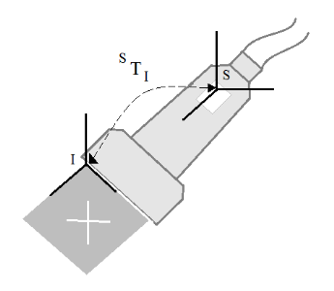
Figure 1. Calibration Process. Shows the matrix STI that relates the coordinate system I and S.

Breast tumor segmentation in ultrasound images
The visualization of breast tumors in ultrasound images may be a difficult task for inexperience users because of inherent artifacts of the ultrasound images. A good segmentation method may be able to help the physician to have a better visualization of the lesion, but it is not an easy image-processing task [Chen]. The main artifacts that make the segmentation of breast tumors a challenging are speckle, acoustic shadows, blurry boundaries and the shape of the tumors; also there are some healthy tissues that may look like tumors in ultrasound images.
There are several works related with the segmentation of breast tumors. Most of these works consist on a pre-processing step and a segmentation step. The pre-processing step consists in a filtering and contrast enhancement of the image. Some works have used Gaussian and Butterworth filters, [Chen] and [Madabushi] respectively, but it has been probe in [Abd] that the Gaussian anisotropic filter, as the one used in [Chang seg], have good results in ultrasound images. The contrast enhancement of the image has been carried away in [Chang], [Chen] and [Huang] with the sticks method, and with a histogram equalization in [Madabushi]. The segmentation step can be divided in two groups, umbralization based methods and classifiers based methods. The formers, implemented in [Chen] [Chang] [Huang] are low computational cost and use the gray-level intensity of the pixels to segments the image; however, these methods are not able to differentiate acoustic shadows from tumors. The latter group use classifiers to segment the images, these are more robust since they use more than one characteristic for classifying the pixels as tumor or healthy tissue; however this are more difficult to implement and the computational cost increments considerably, some of these methods are implemented in [Madabushi], [Huang NN], [Liao], [Liu] and [Jiao]. A good segmentation method must take in account the spatial position, the texture and the intensity of the lesion [Madabushi].

Breast tumor biopsies and 3D elastography
Ultrasound-guided biopsy is a method than can upgrade the accuracy of the procedure by guiding the needle to the lesion; however, as mentioned before, this method has some disadvantages. Several works have been carried on to upgrade the accuracy of stereotactic and ultrasound-guided biopsies. Azar et al. propose the use of a deformable model obtained from a magnetic resonance in [Azar], to plan a stereotactic biopsy. In [Fenster Biopsia] Fenster et al. propose a system that uses the advantages of mechanical 3D ultrasound and stereotactic biopsy. In [Arambula] and [Bada] use tracked instruments and virtual reality to guide the procedure. Most of the works based on deformable models obtain the tissue information from segmented images of MR or CT. One important problem to take into account while taking a biopsy is the tissue displacement due to the interaction of the surgical tools with the tissue. During needle insertion the forces involved tends to push the tissue away from the needle [Ayacavi], non of these papers take into account this problem, only [Fenster Biopsia] uses 3D ultrasound to check if the needle was inserted in the proper place after the insertion. This problem requires a new generation of systems based on adaptive 3D images [Platenik]. We think that 3D freehand ultrasound with deformable models may be a good solution for this problem.
The main problem with conventional elastography is to choose the correct image plane and to apply a non-uniform stress field [Yen]. Mechanical probes have been used in [Kadour] to assist the phsysician in this procedure to obtain better strain images. Another approach to obtain better images is the use of 3D ultrasound, in [Deprez] Deprez et al. use a mechanical probe, while in [Lindop] use 3D freehand ultrasound to obtain the 3D elastography. We think that an adaptive image obtained with 3D freehand ultrasound and deformable models can be used to obtain a good approximation of the 3D deformation of the tissue and with that information obtain a 3D elastography.

Methodology
The implementation of the methods was made in C++ in a MacPro with an Intel Xenon of 2.83GHz processor with 3GB in RAM and Mac OSX 10.6 64bits operating system, using free-access libraries for the processing and visualization of the images. The used libraries are ITK, VTK and IGSTK; these libraries are property of Kitware Inc ( (1)
where is any pixel and is the tumor region. The first expression (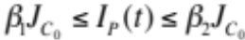) implies that the value of in the probability image 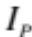 is in between a range of values that depends on the mean value of the seed neighborhood  and the threshold values and 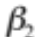; while the second expression 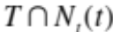 implies that the neighborhood 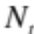 of the pixel intersects with the tumor region.
The tumor edges found with the region growing method can later be used as an initialization for a deformable model like Snakes to propagate the 2D segmentation to the 3D volume like in [Chen seg].

Results
In this section we present the partial results for the reconstruction, calibration and segmentation method. For the calibration and reconstruction methods we use in-vitro validation methods and for the segmentation we use real ultrasound images of breast tumors obtained from an image database of the National Taiwan University.

Calibration
Unfortunately there is no standard method to validate the accuracy of a calibration. The method we use for validating our calibration consists of acquiring several images of a tracked sphere and segmenting several points over the sphere borders manually in each image to obtain an estimated sphere that best fits the segmented points. The accuracy error is reported as the distance between the tracked sphere and the estimated sphere. For evaluating a calibration, obtained with 50 cross-wire images, we use one tracked sphere and acquire 10 images of it and segment 2400 point over the surface; the accuracy error obtained in this calibration was 0.556mm.
Another important calibration error that should be measure is the precision. This error means to the error committed by transforming a single point in different image planes. To obtain this error we acquire several images in different planes of one point. After reconstructing the point in each image, we obtain the absolute standard deviation of the point cloud and report this as the precision error. For the previously mentioned calibration we obtain a precision error of 0.249mm.

Reconstruction
For evaluating the reconstruction error of the implemented algorithm we use an ultrasound phantom (Ultrasound Resolution Phantom Model 044, CIRS) that has tree groups of cylinders. The first group consists of six cylinders of 1.5mm, the second group consists of nine cylinders of 3mm and the third group consists of two cylinders of 12mm. Five reconstructions of each group were made with different voxel size (k = 1, 3, 5, 8 and10). The diameter of the cylinders in each reconstruction was manually segmented; the mean measurements for each group of cylinders and voxel size are reported in table 1.

Segmentation
In figure 5 we present the results of obtaining the probability image of two ultrasound images one that doesn’t contain acoustic shadows and one that that contains acoustic shadows bellow the tumor, figure 5a and 5b respectively. In this figure we can see that the intensity probability image (second column) is not able to get rid of the acoustic shadows bellow the tumor, because these present a gray intensity value similar to the ones found inside the tumor, and the texture probability image (third column) is able to increase the intensity value of the tumor edges. We observe in the fourth column of figure 5, that the joint probability image has a high contrast between the tumor and the healthy tissue; it is also shown in figure 5b that the joint probability image gets rid of the acoustic shadows below the tumor.
The region growing results are shown in figure 6a and 6b for both probability images in figure 5. The first column corresponds to the original image; the second column corresponds to the region that belongs to the tumor; while the third column shows the tumor edges overlapped in the original image. It is important to mention that the result of the region growing method may vary significantly depending on the position of the seed.
Table 1. Measurements of the cylinders in the ultrasound phantom in millimeters; X: Horizontal diameter, Y: Vertical Diameter, --: Not able to measure.
Group 1 |  | Group 2 |  |  |  | Group 3
k | X |  |  | Y | X |  | Y | X |  | Y
10 | 12.87 |  | 12.86 |  | 3.25 |  | 2.91 | -- |  | --
8 | 13.10 |  | 13.35 |  | 3.15 |  | 3.16 | 1.77 |  | 1.70
5 | 12.7 |  | 12.8 |  | 3.14 |  | 3.06 | 1.73 |  | 1.65
3 | 12.9 |  | 13.15 |  | 3.32 |  | 3.05 | 1.66 |  | 1.43
1 | 12.5 |  | 12.7 |  | 13.21 |  | 3.03 | 1.69 |  | 1.64

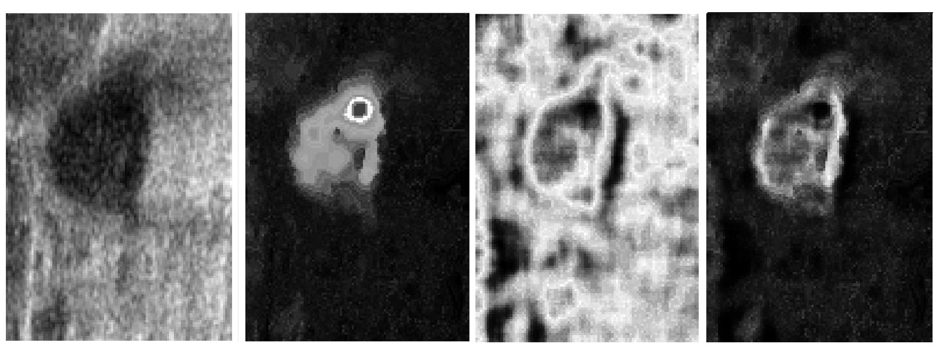
a)
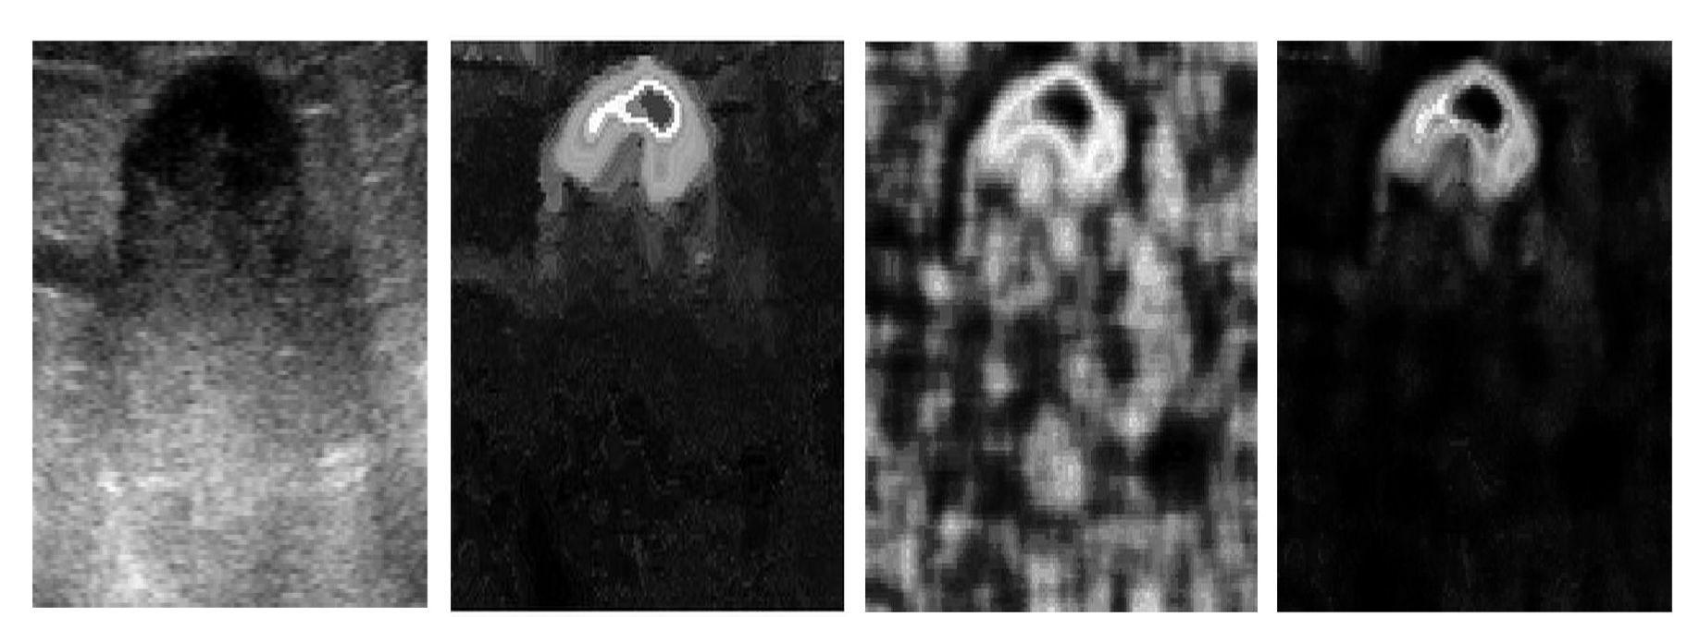
b)
Figure 5. Probability image process. a) Image without acoustic shadows. b) Image with acoustic shadows; Original image in first column; Intensity probability image in second column; Texture probability image in third column; Joint probability image in fourth column.
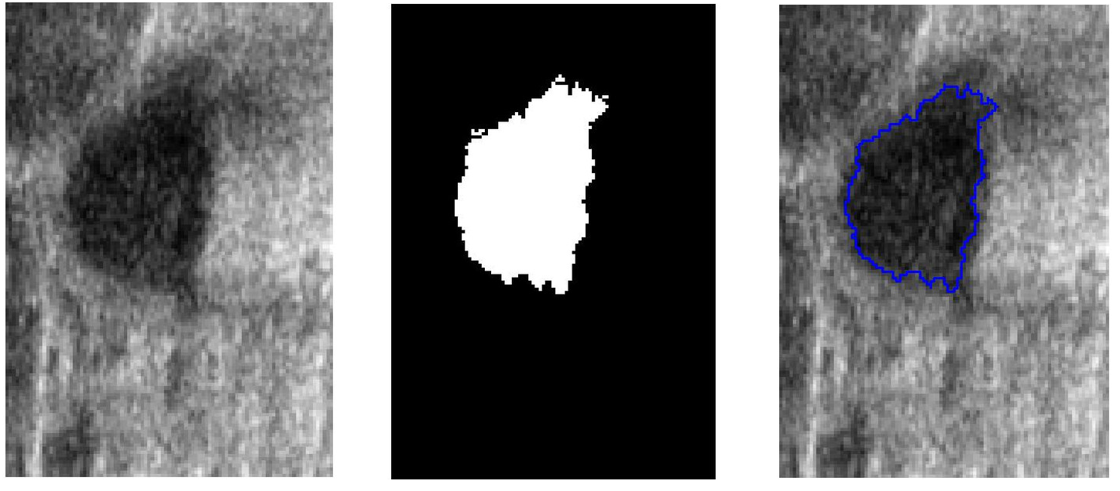
a)
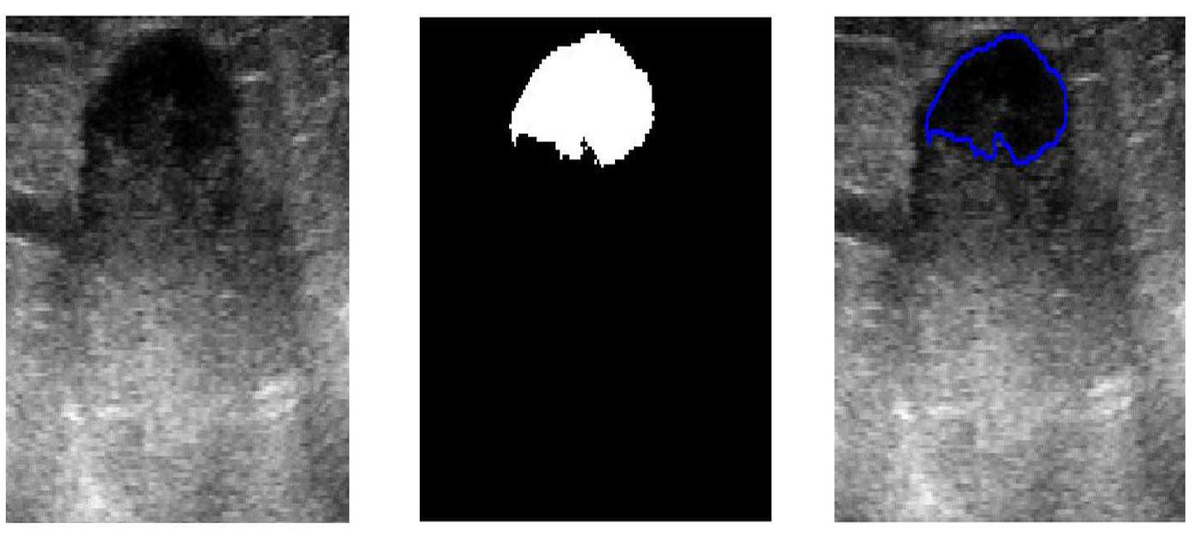
b)
Figure 6. Region growing process. a) Image without acoustic shadows. b) Image with shadows; Original image in first column; Tumor region in second column; Overlapped tumor edges on the original image in third column.

Conclusions and discussion
In this paper we present some methods that could assist the physician in planning and guiding a breast tumor biopsy. These methods could help the physician to have a better understanding of the 3D anatomy of each patient and the position of the. (Abd-Elmoniem, Youssef, & Kadah, 2002) (Abd-Elmoniem, Youssef, & Kadah, 2002)

Center the paper title at the top of the page in 16-pt. bold. Only the first word, proper nouns, and acronyms are capitalized. Keep titles brief and descriptive. Spell out acronyms unless they are widely known. Avoid starting with articles or prepositions, e.g., “The study of … ,” or, “On the ….”

Author affiliations
The author list is in 12-pt. regular, centered. Omit titles and degrees such as Dr., Prof., Ph.D., etc. The list of affiliations follows. Each author's affiliation should be clearly noted.

Section headings
Section headings are 11-pt. bold capitals, centered. Sections numbers have whole numbers, e.g., 1, 2, 3… Don't number the "Acknowledgements" and "References." Headings often used are: 1. Introduction, 2. Methodology, 3. Data, 4. Results, and 5. Conclusions.

Subsection heading
Subsection headings are left-justified, 10-pt. bold. Capitalize the first word, acronyms, and proper nouns.

Paragraphs
Add a blank line above and below section headings and between paragraphs. Avoid headings or one-line paragraphs at the top or bottom of a page by using page breaks or extra blank lines. One method to preserve page breaks is to make the bottom margin a little larger than the specifications. Indentation is optional. This spacing is automatic if you are using the SPIE "section" styles in Word.

Text
Text is 10 point and justified. Each sentence ends with a period and a single space before the next sentence.

Figures and captions
Figures are centered. Use or insert .jpg, .tiff, or .gif illustrations instead of PowerPoint or graphic constructions. Captions go below figures. Indent 5 spaces from left margin and justify.

Figure 1. Figure captions are indented 5 spaces and justified. If you are familiar with Word styles, you can insert a field code called Seq figure which automatically numbers your figures.

Tables and captions
Tables are centered. The caption goes above the table. The caption text should indent 5 spaces from left margin and justify. Table examples are on page 1 and 2 and below.

Multimedia figures – video and audio files
Video and audio files can be included for publication. Table 3 lists the specifications for the mulitimedia files. Use a screenshot or another .jpg illustration for placement in the text. Use the file name to begin the caption. The text of the caption must end with the text "http://dx.doi.org/doi.number.goes.here" which tells the SPIE editor where to insert the hyperlink in the digital version of the manuscript.
Here is a sample illustration and caption for a multimedia file:
Video 2. A label of “Video/Audio 1, 2, …” should appear at the beginning of the caption to indicate to which multimedia file it is linked . Include this text at the end of the caption: http://dx.doi.org/doi.number.goes.here

Table 3. Information on video and audio files that can accompany a manuscript submission.
Item | Video | Audio
File name | Video1, video2, … | Audio1, audio2, …
Number of files | 0-10 | 0-10
Size of each file | max. 5 mb | max. 5mb
File types accepted | .mpeg, .mov (Quicktime), .wmv (Windows Media Player) | .wav, .mp3

Mathematical Equations
Use common fonts like Times Roman in your math equations. A math reference in a paragraph sentence such as 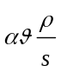 is not numbered. The steps of a mathematical argument can be numbered using a right-aligned tab for clarity, for example
α = 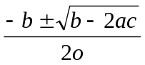 (1)
and
ρ=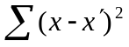. (2)

using THIS TEMPLATE AND ITS Automatic formatting
This document template and more information is available on SPIE.org:
http://spie.org/x14101.xml or by emailing author_help@spie.org

View the pre-formatted styles
To see the formats available with this manuscript, go to the Format menu and choose "Styles and Formatting". To view which style is being used in any part of this document, place your cursor on the line and look in the Styles and Formatting display.

Using SPIE styles
To use this template in Microsoft Word: open this file and save it to a new file name. Type over the existing text with your paper. Alternately, you can delete all text, and select the SPIE style for each paragraph from the Styles and Formatting menu.

Notes on SPIE styles
The styles listed in Table 2 automatically add extra spacing before and/or after paragraphs: SPIE title, SPIE authors-affiliations, SPIE section heading, SPIE subsection heading, and SPIE body text. The 1.1 Heading 2 style automatically goes into the body text style after one paragraph return.

reference linking
SPIE is able to display the references section of your paper in the SPIE Digital Library, complete with links to referenced journal articles, proceedings papers, and books, when available. This added feature will bring more readers to your paper and improve the usefulness of the SPIE Digital Library for all researchers.
Denote reference citations within the text of your paper by means of a superscript number. List references at the end of the paper in numerical order, and enclose the reference number in square brackets. Include the following information (as applicable).
If you use this formatting, your references will link your manuscript to other research papers that are in the CrossRef system. Exact punctuation is required for the automated linking to be successful.
book: [1] Booth, N. and Smith, A. S., [Infrared Detectors], Goodwin House Publishers, New York & Boston, 241-248 (1997).
journal paper: [2] Davis, A. R., Bush, C., Harvey, J. C. and Foley, M. F., "Fresnel lenses in rear projection displays," SID Int. Symp. Digest Tech. Papers 32(1), 934-937 (2001).
proceedings paper: [3] Van Derlofske, J. F., "Computer modeling of LED light pipe systems for uniform display illumination," Proc. SPIE 4445, 119-129 (2001).
website: [4] Myhrvold, N., “Confessions of a cybershaman,” Slate, 12 June 1997, <http://www.slate.com/CriticalMass/97-06-12/CriticalMass.asp> (19 October 1997). www.optics4yurresearch.com/7752.html

References
- Booth, N. and Smith, A. S., [Infrared Detectors], Goodwin House Publishers, New York & Boston, 241-248 (1997).
- Davis, A. R., Bush, C., Harvey, J. C. and Foley, M. F., "Fresnel lenses in rear projection displays," SID Int. Symp. Digest Tech. Papers 32(1), 934-937 (2001).
- Van Derlofske, J. F., "Computer modeling of LED light pipe systems for uniform display illumination," Proc. SPIE 4445, 119-129 (2001).
- Myhrvold, N., “Confessions of a cybershaman,” Slate, 12 June 1997, <http://www.slate.com/CriticalMass/97-06-12/CriticalMass.asp> (19 October 1997). www.optics4yurresearch.com/7752.html
[5] Jones, C. J., Director, Miscellaneous Optics Corporation, interview, Sept. 23 2011
[6] FamilyName, GivenName Initial., "Title," Source, pg# (year).

* fabian.trobles@gmail.com; phone (52) 5622-8601 ext. 1157

